Original Article
A Key Step in Detecting Interstellar Molecules——alcohol, acetic acid, and aldehyde for example
Jack, Jane, Sophie, Stephanie
Abstract
Introduction
The existence and structures of interstellar organic molecules play a positive role in helping astronomers to learn about collision between atoms, formation of lives, and evolution of stars. To meet this end, representative spectra for certain molecules need to be discerned from observation results. The aim of this study was to determine optimal absorbance wavelengths of alcohol, acetic acid, and aldehyde and illustrate the mechanism underlined with molecular orbital theory, revolution theory, and vibration theory.
Experiment
The paper includes the materials and the instrument with its introduction for using it. We also demonstrate the method to utilize all materials and instrument with which the experiment being hold. The essential instrument we use is UV scanning and the main substances we use as samplings are Aldehyde, Acetic acid and Alcohol.
Results
Alcohol and acetic acid show no absorbance in the span between 200 nm and 700nm. Aldehyde, in contrast, shows two clear absorbance peaks, respectively at 230 nm and 298 nm.
Analysis
Transitions of electrons from low-energy orbitals to high-energy orbitals assumed most absorbance of ultraviolet light in certain wavelengths. Representative wavelengths could be used to determine functional groups in molecules passed by light from nebulae or stars. Plus, vibrations and revolution of molecules afford rest absorbance and make spectra continuous, which can be determined by the equation of radiation transfer.
Conclusion
We want to extent the method of searching interstellar molecules in outer space and we hope this process of experiment can enlighten some way of searching. Three organic substances are the samplings when we choose for a better choice for conducting. The results can be clearly seen and based on the statistics we got from the experiment we can figure out a likely way to confine objects in outer space.
Keywords:
Alcohol, Acetic acid, Aldehyde, wavelength, interstellar organic molecules

Introduction
The existence and structures of interstellar organic molecules play a positive role in helping astronomers to learn about collision between atoms, formation of lives, and evolution of stars. To meet this end, representative spectra for certain molecules needs to be discerned from observation results. The aim of this study was to determine optimal absorbency wavelengths of alcohol, acetic acid, and aldehyde and illustrate the mechanism under-lied with molecular orbital theory, revolution theory, and vibration theory.

At present, 47 kinds of molecules have been found in interstellar space, and 80% of which are organic molecules. The discovery of interstellar molecule and interstellar organic molecule breaks away from the dominant view in astronomy that atoms in interstellar space are difficult to bind to molecules, even if they bind to molecules, they will be disintegrated. Interstellar organic molecules are studied by analyzing the microwave lines emitted by molecules through radio telescopes. The discovery of interstellar organic molecules helps us understand the evolution of nebulae and stars, and increases the possibility of extraterrestrial life, which is the basis of interstellar chemistry today. Therefore, it is also known as one of the four great discoveries of astronomy in the 1960s. Using ultraviolet spectrophotometer is the most common treatment for determination of optimal wavelength of organic molecules, so we choose this method to carry our experiment.

In conclusion, this research would determine optimal absorbency wavelength of polar molecule relating both chemistry and physics and explain why some results are not observed, which divides into four parts named experiment, result, analysis and conclusion.

Experiment
The Preparation of Solutions
1. Calculate the mass of acetic acid, ethanol and acetaldehyde according to n=m/M
2. Use the electronic balance to measure the mass of the three materials
3. Put the three substances in a small beaker and dilute them with a little water.
4. After the solution temperature is lowered, transfer the three substances in the beaker to a 500 mL capacity bottle.
5. Wash the beaker and transfer the glass rod, at least three times, then transfer the washing water to the capacity bottle.
6. Add water to the calibration line, and change the volume fixing with rubber head burette about one centimeter away from the calibration line.
7. Shake well the solution, and if the liquid level drops, water cannot be added to set volume.
8. Transfer the solution to the reagent bottle and label it.

Method to use the ultraviolet spectrum
1. First, we charge the UV spectrometer. Except preheating the UV spectrometer, we also need to test the basic function of the machine and initialize it. Then we open the computer.
2. We then take out the medicine or the samplings from the UV spectrometer and close the machine and then open the particular software.
3. We need waiting for the initialization which detects eight elements. There are some cautions including tritium lamp energy detection without taking out the samplings in the groove should be avoided.
4. After we finish the testing, there will pop up five windows. One main window is a small one and then we choose the [UV scanning] and put the control group in the machine. Then we click the [base] in the right tool column to wait for the scanning finished. Then we take out the control group on the outer side and put them in testing group and then click [begin] and to begin the scanning.
5. After scanning, we right click the screen and then we can see the program aiming to dispose the picture. We should set the range of axis and the way tracing point.
6. We then click the left side profile and choose to preserve the picture in the column. Although the preservation can only be served as the form which can be opened in the software, we can screenshot the picture.

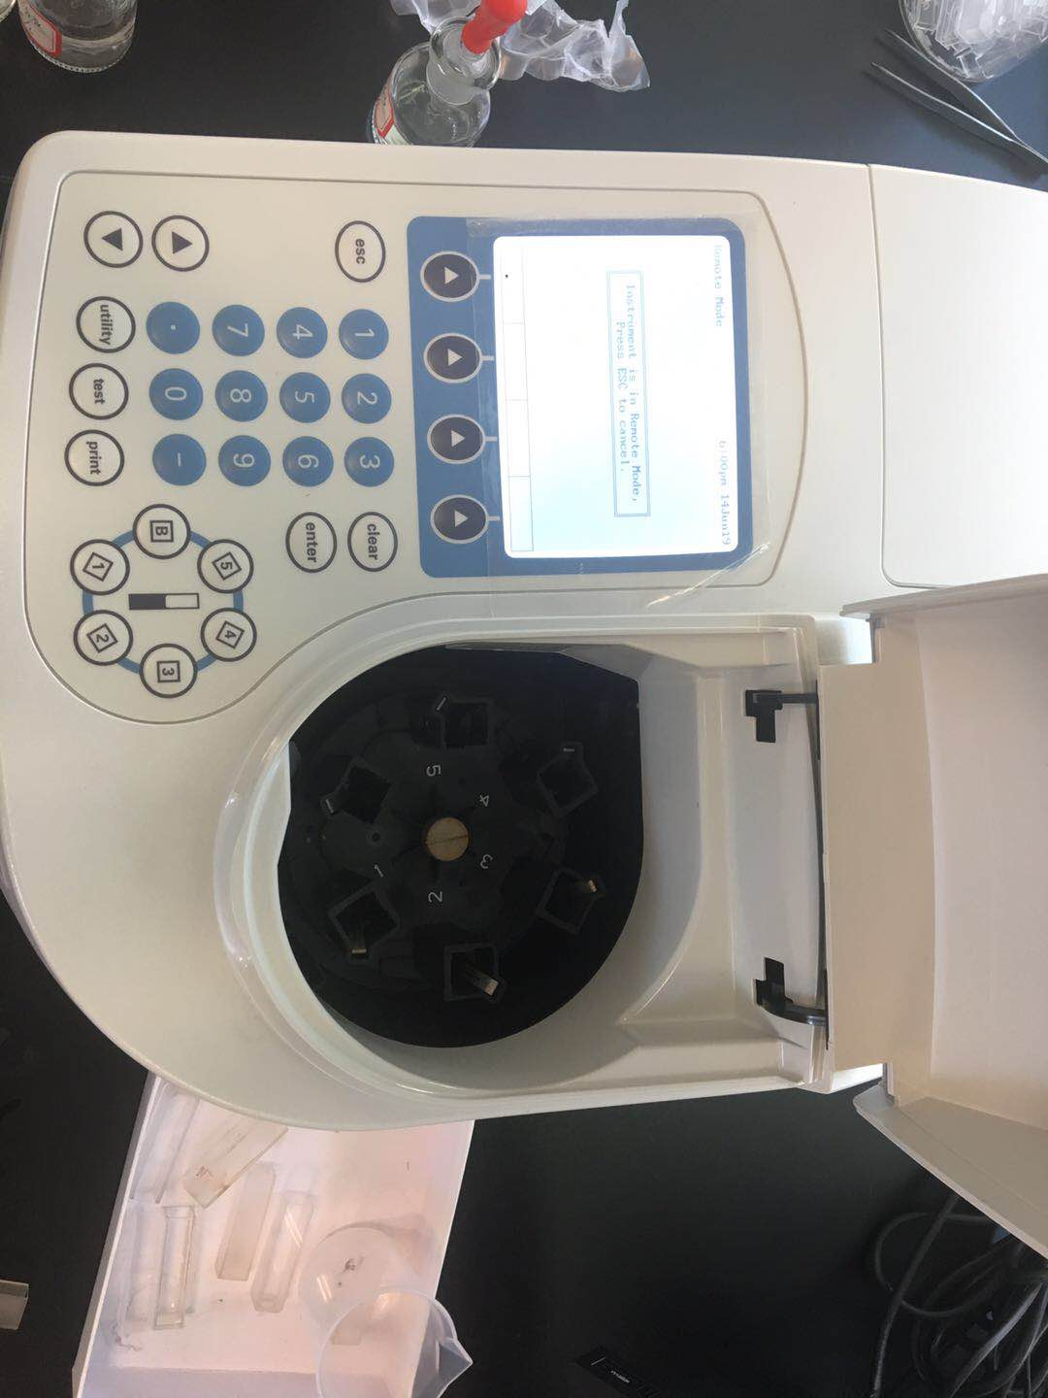
Figure-1

Results

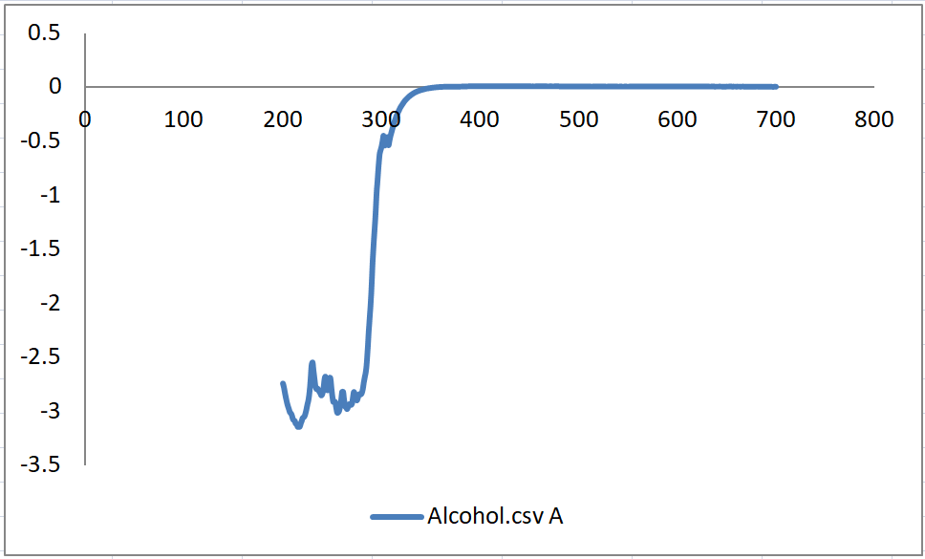
Figure-2.1

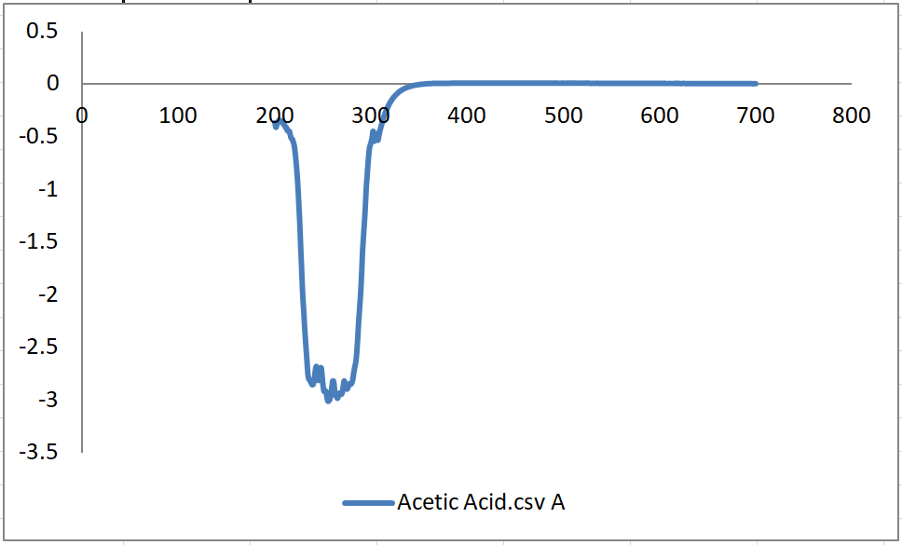
Figure-2.2
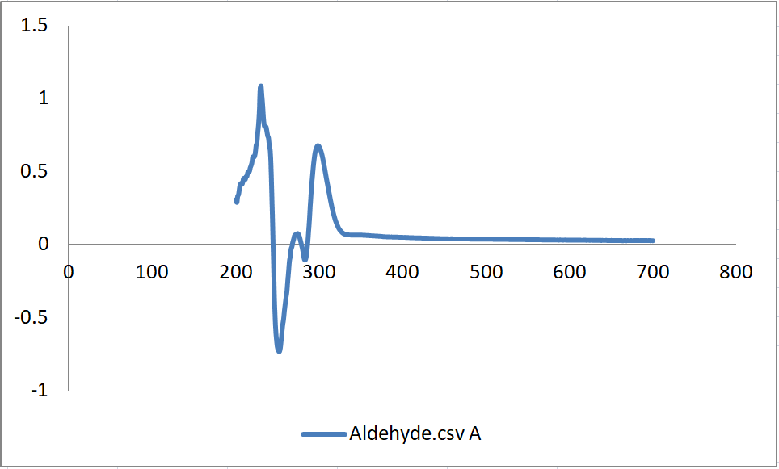
Figure-2.3

Analysis
Absorbance spectrum is the record of particles’ sequence and strength of absorbance. It indicates the presence, concentration, and structure of particles tested. Different from band spectra obtained from atoms, spectra of molecules have continuous features due to electrons’ transition and molecules’ vibration and revolution.

Molecules are in certain energy levels, where higher energy levels are reached when molecules are exited and lower levels returned to ground state, as can be described by the equation $∆E=E_{1}-E_{0}=ην$.

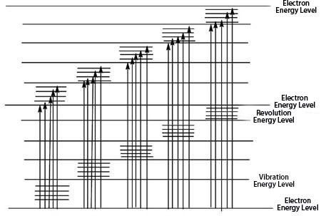
Energy levels in molecules are much more complicated than those of atoms. Total energy of molecules is composed of multiple parts, following this equation $E_{Total}=E_{I}+E_{T}+E_{E}+E_{V}+E_{R}$. $E_{I}$ refers to internal energy, with no relation to molecules’ transition in energy level since internal energy remains the same during transitions. $E_{T}$ refers to molecules’ translational kinetic energy, only as a continuous function of temperature and with no correlation with transitions between energy levels. $E_{E}$ here refers to valence electron energy, the energy produced when electrons move relatively to the nucleus, and assumes most energy transitions, where two nearby energy levels have a difference of 1-20eV. $E_{V}$ refers to vibrational energy, which is produced when molecules vibrate around the equilibrium position and which affects spectra produced and provides information of bond types, and have a 0.025-1 eV difference between two nearby energy levels. $E_{R}$ refers to rotational energy, which is produced when molecules revolve around the gravity center and affects received spectra, has a difference of 0.004-0.025eV between two nearby energy levels, and gives information about bond lengths, bond types, and hyperfine structures of molecules, observed in infrared spectra. $E_{V}$ and $E_{R}$ assume the vacancy between two electron energy levels and make the spectra continuous. Therefore, it can be determined that in transition process only involves $E_{E}$,$E_{V}$, and $E_{R}$.
Figure-3.1

If the molecule absorbs energy less than 0.025eV, only revolution of the molecule is involved. If the molecule absorbs infrared light, both its vibrations and revolutions are evoked. If the molecule absorbs light of wavelengths between 200 nm and 800 nm, transitions of electrons are produced, and ultraviolet-visible spectra occurs. Thus, when there are transitions of electrons, there must be vibrations and revolutions, which correspond to lower energy level and produce continuous spectra, as shown by the following figure.

Organic molecules, such as acetic acid, aldehyde, and alcohol used in the experiment, absorb mainly the ultraviolet light due to electrons transitions. Molecules with double bonds or multiples bonds—— that is, molecules with resonance structures—— are most likely to have obvious absorbance.

According to the Molecular Orbital Theory, organic molecules possess following several orbitals of electrons around nuclei. First, sigma (σ) molecular orbitals. The electron probability of both molecular orbitals is centered along the line passing through the two nuclei. Electrons in sigma orbitals are referred as sigma electrons. For bonding orbital, the probability is between the nuclei, and for the antibonding either side. A bonding molecular orbital is lower in energy than the atomic orbitals of which it is composed. The bonding orbital is formed when phases of both orbitals match between the nuclei to produce constructive interference. This leads to enhanced electron probability between the nuclei. Electrons in this type of orbital will favor the molecule; that is, they will favor bonding. An antibonding molecular orbital is higher in energy than the atomic orbitals of which it is composed. The antibonding orbital is formed by the direct combination of the orbitals, which gives destructive interference of the positive phase of one orbital with the negative phase of the second orbital. This produces a node between the nuclei, which gives decreased electron probability. Electrons in this type of orbital will favor the separated atoms. Second, pi (π) molecular orbitals. The electron probability of both molecular orbitals lies above and below the line between the nuclei. Electrons in pi orbitals are referred as pi electrons. Following the same mechanism of sigma orbitals, bonding orbitals are formed when phases of two parallel orbitals match, and antibonding appears if positive phase of one orbital meets the negative phase of the other orbital. All in all, molecular sigma and pi orbitals can be formed only when the symmetry of two orbitals matches. Third, n molecular orbitals. Electrons in these orbitals are referred as n electrons and do not interact with electrons in the orbital of the other nucleus.

In the molecular orbital model, electrons still conform with Pauli Exclusion Principle, Aufbau Principle, and Hund Rule.

When organic molecules absorb certain amount of energy, valance electrons will transit to higher energy levels, which can be categorized as following 4 types. First, N to V transition. Electrons in this transition are transferred from the ground state to the antibonding orbital. Second, N to R transition. Electrons in this transition are transferred from the n orbital to the antibonding orbital. Third, N to R transition. Electrons in this transition are excited gradually from sigma orbitals to higher energy levels, finally ionizing the molecule. Fourth, transition of charges. Charges in this transition are redistributed and transferred to other parts within the molecule. In terms of energy, these transitions can be ranked as following:
$$σ→σ^{*}>n→σ^{*}>π→π^{*}>n→π^{*}$$

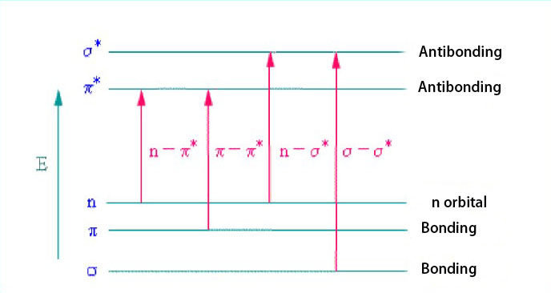
Figrue-3.2

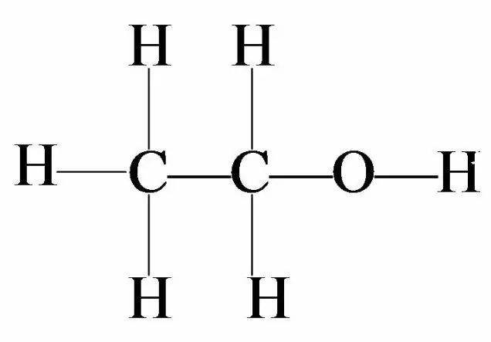
In this experiment, where samples are scanned through 200 nm to 700 nm, alcohol and acetic acid have negative absorbance values. The mechanism of the spectrometer is simultaneously setting up a comparison sample—— which is water here since our solutions are diluted with water—— and testing samples. After receiving the absorbance of testing samples，softwire VISIONite subtracts the received value of absorbance with that of the water. Here some parts of absorbance of alcohol and acetic acid are negative. We can get clues of their respective molecular structures.
Figure-4.1

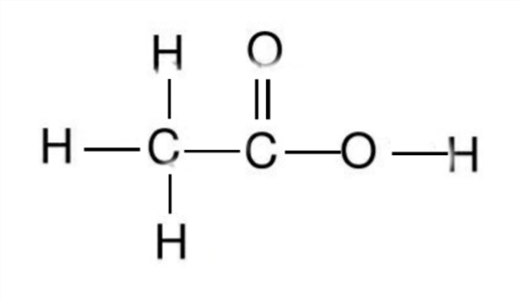
Above is the molecular structure of alcohol, which has only sigma (σ) electrons. Therefore, there is only $σ→σ^{*}$ transition occurring when excited. This type of transition requires high energy, which especially occurs in the carbon bond in organic molecules, and appear in the span between 10 nm and 200 nm; that is, it is in the far-ultraviolet region. This pattern explains why in the absorbance spectrum of alcohol shows no absorbance in the span of wavelength between 200 and 700 nm, which is the only region scanned by our Ultra-visible spectrophotometer.
Figure-4.2

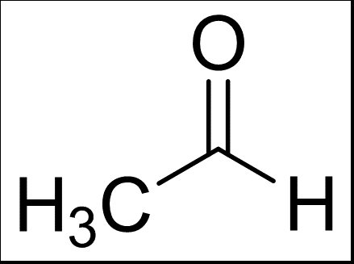
Similarly, acetic acid also does not show absorbance between 200 nm and 700 nm. $n→σ^{*}$ occurs and also requires relatively high energy, and absorbance appears in nearly 183 nm_{[6]}. Hydroxyl here acts as auxochrome lengthening the wavelength of absorbance. The fact is, absorbances of alcohol and acetic acid are detectable as long as in the right span of wavelength, which is feasible in astronomical observation.
Figure-4.3

In contrast, aldehyde shows two clear peaks of absorbance. To calculate the energy of absorbance, we need to use the Plank Formula $E=\frac{hc}{λ}$. The first one shows an absorbance wavelength of 230 nm and absorbance energy of 5.394 eV. K absorbance band occurs due to $π→π^{*}$ transition. As the conjugate system enlarges, the influence of π electron cloud decreases, thus energy required smaller and wavelength much larger. K absorbance band is the representative characteristic of organic molecules, which can then be used to determine the conjugate structure in molecules. The second one shows an absorbance wavelength of 298 nm and 4.163 eV. R absorbance band occurs due to $n→π^{*}$ transition, caused by the conjugate group in aldehyde. Normally, $n→π^{*}$ transition needs relatively small amount of energy and thus have a larger absorbance wavelength than that of K absorbance band.

Besides, electron transitions are demonstrated by ultra-violet spectra, whereas vibrations of molecules are showed by infrared spectra. Vibrations of molecules can be approximated as simple harmonic motion and comply with the Hooke’s Law. Also, the revolution of molecules help make the spectrum continuous, giving astronomers a glimpse into hyperfine structure_{[7]}. Here is the radiation transfer equation:
∑n(i)×C(i , l)+ i
∑n(i)×B(i , l)×U(i , l)+ i
∑n(i)×A(i , l) i
= ∑n(l)×C(l , i)+ i
∑n(l)×B(l , i)×U(l , i)+ i
∑n(l)×A(l , i)

Conclusion
By conducting this experiment and analysis, we want to further explore the possible method to detect objects in the outer space. The samplings (Alcohol, Acetic acid and Aldehyde) are organic substances and can be shown their ultraviolet absorption and obvious spectrum easily. When it occur in the outer space which may contains floating tremendous objects able to be detected their ultraviolet absorption, the experiment and the result in the paper can be a good lighthouse for further research about interstellar molecules.

Literature Review
[1] Karas, Michael.， Bachmann, Doris.， Hillenkamp, Franz, Influence of the Wavelength in High-Irradiance Ultraviolet Laser Desorption Mass Spectrometry of Organic Molecules. Analytical Chemistry 57(14) · December 1985
[2] Peter L. Smith, Ultraviolet observations of interstellar molecules and grains from Space lab. Proceedings of the Astronomical Union 1980, vol 81, pp 645-660
[3]
John H. Black, Ultraviolet-visible-and-infrared-spectroscopy-of-interstellar-molecules. Highlights of Astronomy 1981, pp. 331-338
[4] Black, J. H, Visible and ultraviolet studies of interstellar molecules. Molecular Astrophysics 1985, pp 215-236
[5] Molecular motion corresponds to three levels of electronic energy level, vibrant energy level and rotational energy level. https://wk.baidu.com/view/e9821f6c580102020740be1e650e52ea5518cede
[6] The Maximum Absorption of Wavelength https://wk.baidu.com/view/3f5db4ac951ea76e58fafab069dc5022aaea46a9
[7] Fei CHUN, Interstellar Molecules and their spectra. Journal of Atomic and Molecular Physics, April 2004.

